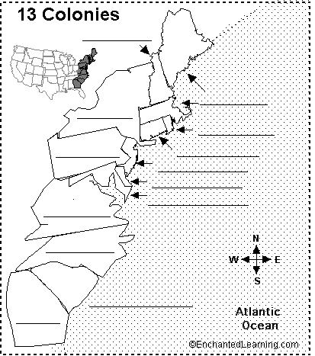
Label the map of the 13 colonies. You may use the word bank below.
Connecticut  Delaware  Georgia  Maryland | Massachusetts  New Hampshire  New Jersey  New York | North Carolina  Rhode Island  Pennsylvania  South Carolina | Virginia

