**C:\Users\meredith peterson\AppData\Local\Microsoft\Windows\Temporary Internet Files\Content.IE5\X8351C0B\MC900022330[1].wmf**C:\Users\meredith peterson\AppData\Local\Microsoft\Windows\Temporary Internet Files\Content.IE5\8TNIR41K\MC900150095[1].wmf**CSI:** SOCIAL STUDIES

Curriculum Support Information

Native Americans & Explorers .

**Students will:**   **Fourth Grade 1 of 7**

**History:**

* Locate where different Native American groups settled
* Describe how Native Americans used their environment for food, shelter, and clothing
* Describe the purpose, obstacles, & achievements of European exploration
* Describe examples of cooperation and conflict between the Native Americans & Europeans

**Geography:**

* Explain why Native American groups settled where they did
* Explain why some tribes had permanent villages and others did not
* Describe how the Europeans adapted (or did not adapt) to their new environment

**Economics:**

* Describe opportunity costs of European exploration

**Native American Tribes:**

1. Inuit (Arctic) 2. Kwakiutl (Northwest)

3. Nez Perce (Plateau) 4. Hopi (Southwest)

5. Pawnee (**Great Plains**) 6. Seminole (Southeast)

**Explorers (listed in order by country but numbered chronologically):**

**Spain (explored S. America/southern N. America)**

1. Christopher Columbus (1492) – Discovered America on accident

3. Vasco Nunez Balboa (1509) – First European to see the Pacific Ocean

4. Juan Ponce de Leon (1513) – First European to set foot in Florida

**France (Explored northern N. America)**

5. Jacques Cartier (1534) – Claimed Canada for France & discovered the

**St. Lawrence River**

**England (Explored northern N. America)**

2. John Cabot (1497) – Discovered a great fishing area in Canada &

found fool’s gold which he gave to the king

6. Henry Hudson (1607) – Discovered Hudson Bay, Hudson River, &

Hudson Straight in present-day New York

**Terminology (make flashcards or practice on Ms. Peterson’s website):**

**Adapt:** Fit a person’s way of living to the land and its resources

**Ancestors:** Early family members

**Barter:** To exchange or trade goods

**Ceremony:** A series of actions performed during a special event

**Clan:** Group of families related to each other

**Desert:** Dry land with few plants

**Dugout:** A boat made from a large, hollowed-out log

**Glacier:** Slow moving sheets of ice

**Harpoon:** Long spears with sharp shell points

**Igloo:** Dwelling made of large blocks of ice stacked into a dome shape

**Lodge:** Large circular houses built over a shallow pit covered with sod which were shared by many families

**Mesa:** Flat-topped mountain with steep sides

**Plain:** Area of flat or gently rolling, low land

**Plateau:** Area of high, mostly flat land

**Potlatches:** A special Native American gathering or celebration with feasting and dancing

**Pueblo:** Spanish word for village

**Staple:** Main foods that a tribe would eat

**Surplus:** An amount of an object or food that is more than what is needed

**Totem pole:** A cedar pole carved with shapes and animals

**Tribe:** A term often used to describe a group of Native Americans who share a language and customs.

~~~~~~~~~~~~~~~~~~~~~~~~~~~~~~~~

**Astrolabe:** An instrument to calculate the positions of the Sun, moon, and stars

**Claim:** To declare ownership of new land

**Compass:** An instrument used for finding direction

**Encounter:** Meeting

**Estuary:** The wide mouth of a river where the ocean tide flows into the river

**Expedition:** Journey of exploration

**Grant:** A sum of money or other payment given for a particular reason

**Historical map:** Gives information about a place as it was in the past

**Isthmus:** A narrow strip of land that connects two land areas

**Monarch:** Kings and queens

**Mutiny:** Rebellion against the leader of a group

**Navigation:** Skill of controlling the course of a ship

**Opportunity cost:** What is given up in exchange for something

**Profit:** Money left over after the goods have been sold and the cost of getting them has been paid

**Treaty:** An agreement between nations about peace, trade, and other matters

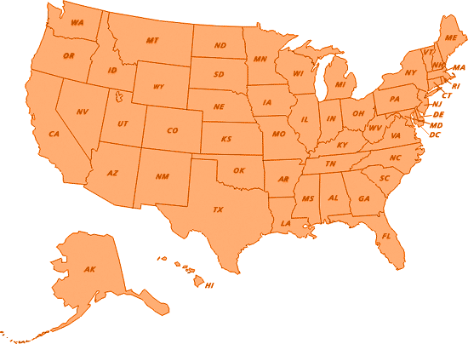

5

6

1

4

3

2