C:\Users\meredith peterson\AppData\Local\Microsoft\Windows\Temporary Internet Files\Content.IE5\GKW7K4RP\MC900199021[1].wmf**C:\Program Files\Microsoft Office\MEDIA\CAGCAT10\j0293828.wmf CSI:** SCIENCE

Curriculum Support Information

**Terminology (make flashcards):**

**Water cycle:** The constant recycling of water on earth

**Solid:** The state of matter that has a definite shape and takes up a definite amount of space

**Liquid:** The state of matter that takes the shape of its container and takes up a definite amount of space

**Gas:** The state of matter that has no definite shape and takes up no definite amount of space

**Evaporation:** The process by which a liquid changes to a gas

**Condensation:** The process by which water vapor changes from a gas to a liquid

**Clouds:** Many tiny drops of water or tiny ice particles floating together in the air that are attracted to dust particles

**Dew:** Water droplets that form on earth when the air temperature drops

**Fog:** Cloud of fine drops of water just above the earth’s surface

**Precipitation:** Water that falls to earth as rain, sleet, snow, or hail.

**Rain:** Water falling in drops from clouds

**Hail:** Small, round pieces of ice formed in thunderclouds that fall from the clouds

**Sleet:** Partly frozen rain or ice pellets

**Snow:** Water frozen into crystals that fall to the earth in soft white flakes and often spread upon it as a white layer

~~~~~~~~~~~~~~~~~~~~~~~~~~~~~~~~~~~

**Weather:** Conditions of the atmosphere with respect to temperature, wind, humidity, cloudiness, etc.

**Meterorologist:** A person that studies atmospheric conditions

**Anemometer:** Measures wind speed

**Barometer:** Measures air pressure

**High pressure:** Usually indicates bad weather

**Low pressure:** Usually indicates good weather

**Air mass:** A large body of air that has similar temperature and humidity throughout

**Front:** A place where two air masses meet up

**Humidity:** The amount of moisture in the air

**Rain gauge:** Measures rainfall

**Thermometer:** Measures temperature

**Fahrenheit:** Temperature scale that registers freezing at 32o and boiling at 212o

**Celsius:** Temperature scale that registers freezing at 0o and boiling at 100o

**Wind vane:** Measures wind direction

**Climate:** The average temperature and rainfall of an area over many years

Water Cycle & Weather .

**Students will:**   **Fourth Grade 2 of 5**

* Demonstrate how water changes state (from solid🡪liquid🡪gas)
* Identify the temperature at which water changes state (solid & gas)
* Investigate how clouds are formed
* Explain the water cycle
* Investigate different forms of precipitation & sky conditions
* Identify weather instruments and explain how each one is used
* Interpret weather conditions using a weather map
* Use observations and record weather conditions to predict patterns
* Differentiate between weather and climate

**Classroom Cases:**

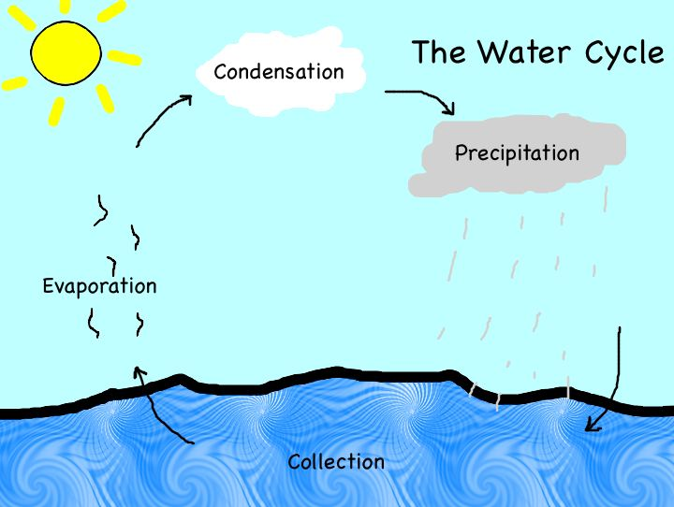

|  |  |  |
| --- | --- | --- |
| **Instrument** | **Use** | **Example** |
| Anemometer | Measure wind speed | http://salestores.com/stores/images/images_747/AN400.jpg |
| Barometer | Measures air pressure to predict upcoming weather patterns – low pressure indicates a high chance of rain while high pressure indicates a lower chance of rain. | http://www.chinalabsupplies.com/weather_kit/DB%20-01_Dial_Barometer1.JPG |
| Hygrometer | Measures humidity in the air. The more humidity there is in the air, the higher chance of rain there is. | http://www.bearwood.com/media/hygrometer_ivory.jpg |
| Rain gauge | Measures rainfall | http://www.infoplease.com/images/cig/weather/21fig06.png |
| Thermometer | Measures temperature. Can measure in Fahrenheit or Celsius. We use Fahrenheit in America. Most of the rest of the world uses Celsius. | **C:\Users\Meredith\AppData\Local\Microsoft\Windows\Temporary Internet Files\Content.IE5\21C65X5Z\MC900413624[1].wmf** |
| Wind vane | Measures wind direction | **C:\Users\Meredith\AppData\Local\Microsoft\Windows\Temporary Internet Files\Content.IE5\21C65X5Z\MP900406913[1].jpg** |

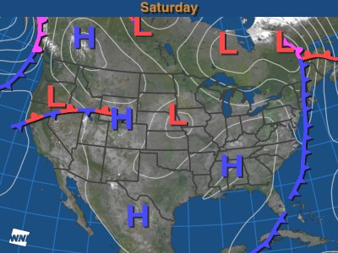

C:\Documents and Settings\meredith peterson.DCBE.147\Local Settings\Temporary Internet Files\Content.IE5\40T5SEVJ\MC900383576[1].wmf

**Further Investigations**

Remember to check out

Ms. Peterson’s website at

<http://mspetersonsroom.weebly.com>. Here, you will find the Investigations for this unit.

* To the left, you will see an example of a weather map used by meteorologists. Weather maps show areas of high and low air pressure as well as predicted precipitation.
* To the right, you will see an example of the water cycle. This is a continuous process that happens on Earth – it never ends or stops!
* Below, you will see a chart of weather instruments.