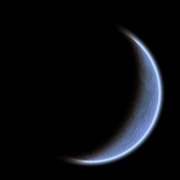**C:\Users\meredith peterson.DCBE\AppData\Local\Microsoft\Windows\Temporary Internet Files\Content.IE5\F09JFE3X\MC900083185[1].wmf CSI:** SCIENCE

Curriculum Support Information

Solar System . .**Students will:**  **Fourth Grade 4 of 5**

* Recognize physical attributes (number, size, color, patterns) of stars in the night sky
* Compare and contrast planets and stars in appearance, position, and number in the night sky
* Explain why the pattern of stars in constellations appears to stay the same, but a planet can be seen in different locations
* Explain Earth’s day/night cycle using a model
* Explain the sequence of the phases of Earth’s moon
* Explain Earth’s seasons by demonstrating the revolution of the earth around the sun
* Demonstrate the relative size and order from the sun of the planets in our solar system

**Classroom Cases:**

* The **rotation** of the earth causes **day and night**. It takes Earth **24 hours** to rotate on its axis 1 time. The earth rotates to the east.
* The **revolution** of the earth causes the **seasons**. It takes Earth a little over **365 days** to revolve around the sun 1 time. Because it takes a little more than 365 days to make a full revolution, we have an extra day every four years – this is called Leap Year. This is why February 29 only comes every four years.
* It takes the **moon**

about **28 days** to

**revolve** counter-

clockwise around

Earth 1 time. It

reflects the light of

the sun which is how

we can see the moon

in the night sky. The

moon does not rotate

so we see it in phases.

When we see the right

side of the moon, it’s

getting bigger. This is called waxing. When we see the left

side of the moon, we know that it has almost made a full

revolution. We call that waning.

**Terminology (make flashcards and practice them for 15 minutes each night):**

**Rotate:** To spin around an axis - *this is what the earth does to cause day & night*

**Axis:** An imaginary line that runs through the center of Earth from the North Pole to the South Pole

**Revolve:** To travel in a closed path – *this is what the earth does to cause the seasons*

**Orbit:** The closed path of one object in space around another object; or to move in such a path

**Moon:** A natural body that revolves around a planet

**Phase:** One of the shapes the moon seems to have as it orbits Earth

**Solar system:** A star and all the planets and other objects that revolve around it

**Planet:** A large body that revolves around a star

**Comet:** A ball of rock, ice, and frozen gases that revolves around the sun

**Star:** A huge ball of superheated gases

**Sun:** The star at the center of our solar system

**Constellation:** A pattern of stars that form an imaginary picture or design in the sky

**Galaxy:** A huge system of gases, dust, and many stars

**Universe:** Everything that exists in space

**Order of the planets from the sun**

“My very earnest mother just served us noodles.”

**1. Mercury**

**2. Venus**

**3. Earth**

**4. Mars**

**5. Jupiter**

**6. Saturn**

**7. Uranus**

**8. Neptune**

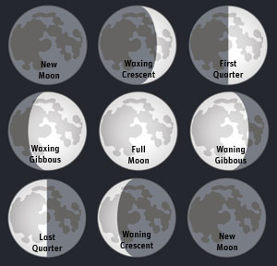

Day 7

Day 1

Day 14

**Order of the planets by size (smallest🡪largest)**

“Miss Mary’s vague evidence nearly upset Suzy Jones.”

1. **Mercury**
2. **Mars**
3. **Venus**
4. **Earth**
5. **Neptune**
6. **Uranus**
7. **Saturn**
8. **Jupiter**

Day 1

Day 28